Power BI Governance

Table of Contents
Overview 1
Roles 1
Licenses 1
Capacity 1
Security 1
Sharing 2
Group 2
Specific user 2
Workspaces 2
Apps 2
Embed 2
Web 2
Teams 2
Sources 2
Reporting 3

Overview
The purpose of this document is to give you a governance starting point for the Microsoft Power BI service within your organization. You will need to add to and modify this document to fit your organization’s needs. Feel free to use this template in continuing your journey with Microsoft Power BI.
Author: Daniel Glenn – DanielGlenn.com

Roles
Classify groups of people using data to make business decisions. Learn more about Power BI service administrator roles: https://docs.microsoft.com/en-us/power-bi/admin/service-security-sensitivity-label-overview
Persona | Description | Role | Notes
Data Scientist
Generalists
Leadership
Admins

Licenses
Note which licenses your organization will use and who will use them. Will you allow self-service sign-up and purchasing? Learn more about self-service: https://docs.microsoft.com/en-us/power-bi/admin/service-admin-disable-self-service
License | Based | Users | Approvers | Notes
Power BI Free | User-based
Power BI Pro | User-based
Power BI Premium Capacity | Capacity-based
Power BI Premium Per User | User & Capacity based

Capacity
Define what types of data should go into each type of capacity, based on storage, refreshing, and dataset size. Also, who decides what is needed?
Data Type | Capacity | Description | Notes
Organizational Finance Approved | Dedicated

Security
Define authentication, Access, and Data Protection
How do internal and external users authenticate?
How is content access managed? (Azure AD; Microsoft 365 Groups; Security Groups, etc.)
What labels and classifications are needed? Learn more about sensitivity labels in Power BI: https://docs.microsoft.com/en-us/power-bi/admin/service-security-sensitivity-label-overview

Sharing
Define how you will share for all of the following items. Will you have a system to have planned external sharing – that is pre-populating external users as guests in your Azure AD, or will you have your users invite them ad hoc? Learn more about using Azure AD B2B for external guests: https://docs.microsoft.com/en-us/power-bi/admin/service-admin-azure-ad-b2b
How do you share ?
If & how to add external users.
Where should sharing happen?

Group
How will you use Microsoft 365 Groups?

Specific user
Will you allow sharing to individual users?

Workspaces
Who can create Workspaces and how many people should be listed as owners?

Apps
Who can publish organizational apps that are known as approved?

Embed
Will users be able to embed Power BI reports on your on-premises sites, including SharePoint?

Web
Who can share reports via the ‘publish to web’ functionality?

Teams
Should you promote sharing in Microsoft Teams? Should users be trained on access/permissions before doing so?

Sources
What data sources are allowed to be used for reports in your organization? Who defines the source of truth? What certification processes will you have?
Learn more about enabling content certification: https://docs.microsoft.com/en-us/power-bi/admin/service-admin-setup-certification

Reporting
What are your service usage reporting needs? Who needs to see the reports? How will you track adoption, usage, and data compliance?
Who are gets the Power BI Admin role in Microsoft 365 and therefore has access to the Usage Metrics https://app.powerbi.com/admin-portal/usageMetrics?
Who needs access to the Microsoft 365 Unified Audit Log so Power BI activities can be tracked?
Which of the following activities need to be tracked on an ongoing basis?
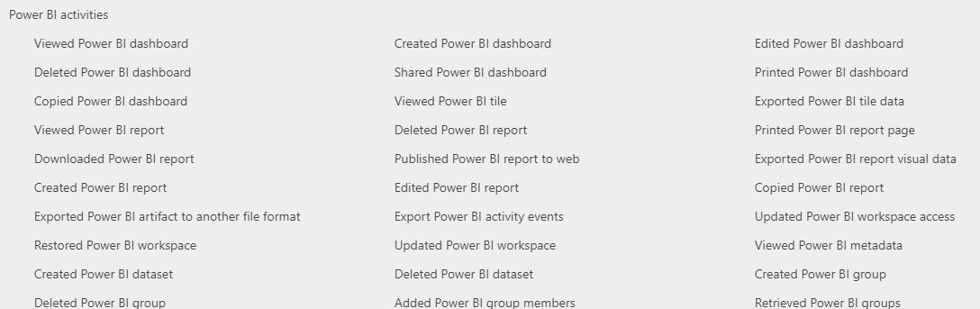
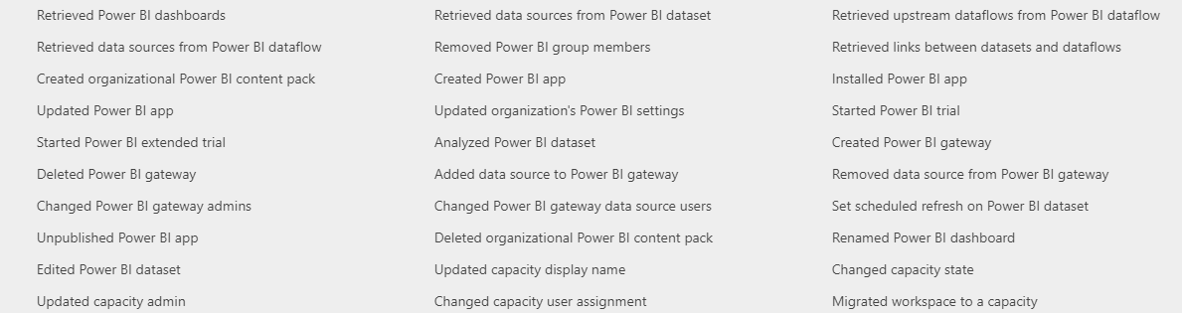
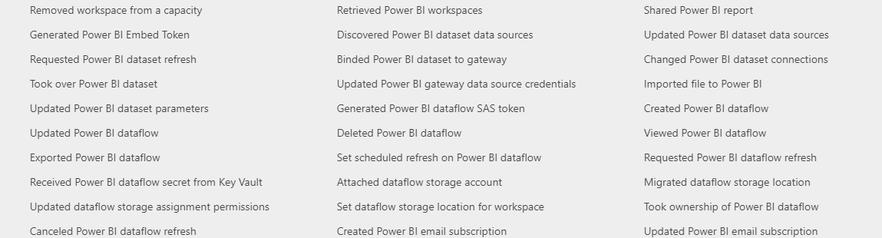
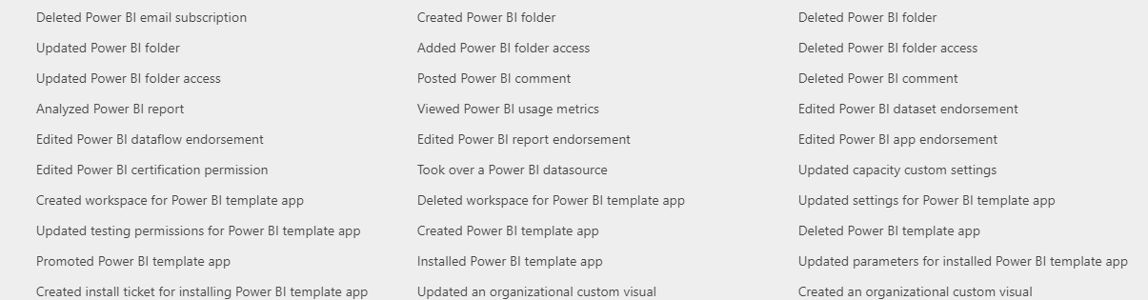
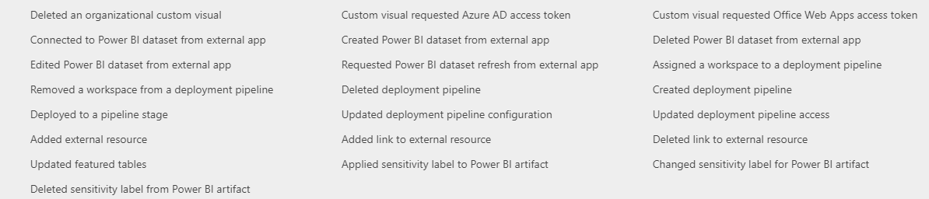

Activity | Frequency | Responsible Personnel | Informed Personnel

More info on the service admin auditing in Power BI: https://docs.microsoft.com/en-us/power-bi/admin/service-admin-auditing

